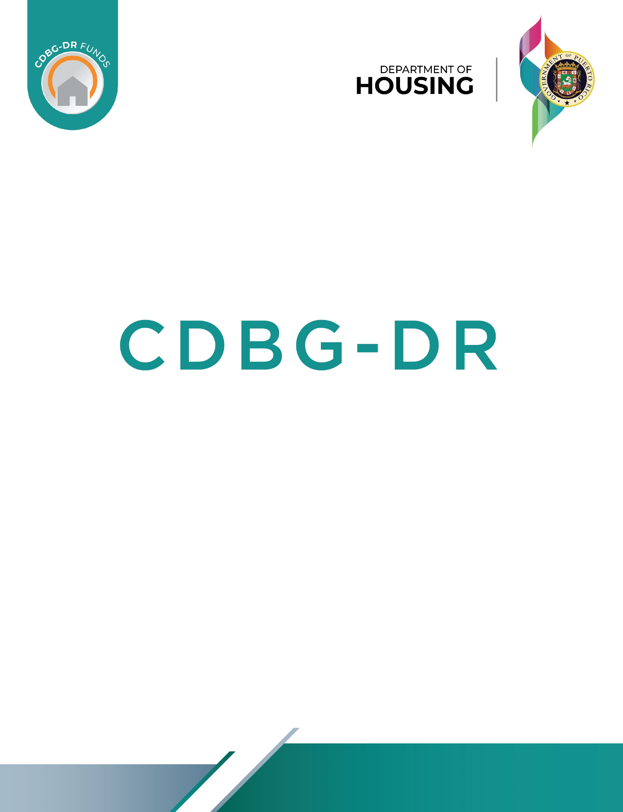

2021 Section 3 Plan
[Name of Contractor]
[Address, Email, Phone]

[Website]

[Name of Authorized Representative]
[Project Name(s)]
[Date]
September 10, 2021
V.2

Table of Contents
1 Overview and Instructions for the Contractor Section 3 Plan Template 3
2 Basic Information 4
2.1 Section 3 Policy Overview 4
2.2 Section 3 Plan Purpose 5
3 Goals for Training, Employment, and Contracting Opportunities 6
4 Section 3 Business 8
5 Section 3 Business Self-Certification Form Review 9
6 Section 3 Workers/Targeted Workers Self-Certification Form Review 9
7 Conducting Outreach and Documentation of Outreach Efforts 9
8.1 Section 3 Training & Employment Efforts to be Performed for Section 3 Targeted Workers and Section 3 Workers 9
8.2 Section 3 Business Efforts to be Performed to Award Contracts to Section 3 Business Concerns 10
8 Section 3 Reporting & Recordkeeping 12
9 Section 3 Complaints Process 14
10 Signature 14

Overview and Instructions for the Contractor Section 3 Plan Template
The purpose of this template is to provide contractors with a Section 3 Plan template to support compliance with Housing and Urban Development (HUD) Section 3 hiring, training, and contracting goals as they apply to Section 3 covered projects. Use of this template and the provision of supporting documentation is voluntary. Contractors may choose to provide PRDOH with an alternate plan and supporting evidence of compliance with Section 3 goals, to the greatest extent feasible.
A Contractor Section 3 Plan must include the following at minimum:
- Contractor Basic Information: name, address, contact information, and website.
- Identification of a Section 3 Coordinator.
- Identification of the Service Area or Neighborhood of the Project.
- Provide specific information about the contractor’s current workforce and any foreseeable hiring needs.
- Provide specific strategies for hiring Section 3 Workers and Targeted Section 3 Workers.
- Provide specific strategies for training Section 3 Workers and Targeted Section 3 Workers.
- Provide specific strategies for subcontracting Section 3 Business Concerns.
- Provide a specific plan for engaging Section 3 designated businesses and, if applicable, each HUD Section 3 certified business that will participate in the contract.
- Provide a description of the work each named Section 3 Business Concern will perform with the dollar amount of participation and estimated labor hours for Section 3 Workers and Section 3 Targeted Workers.
- A firm commitment to include the PRDOH “Model Contract Section 3 Clause” in all sub-contracts.
- A firm commitment to conduct outreach and notifications to potential Section 3 Workers and potential Targeted Section 3 Workers and businesses of hiring opportunities using site signage, flyers, etc.
- A firm commitment to complete, document and report efforts that will be made to notify Section 3 Workers, Targeted Workers & Business Concerns of hiring, training or contracting opportunities generated by HUD financial assistance for housing and community development programs, to the greatest extent feasible.
- A firm commitment to review Section 3 Self-certification forms and request supporting documentation as needed.
- Provide a process for any Section 3 Complaints to be filed and addressed and agree to notify PRDOH in the event of such complaints.
- Indicate ability to complete required labor hour reporting for Section 3 Workers/Targeted Workers on a quarterly basis using the form set forward by PRDOH and submission of the report.
This template contains Tables A, B, C1& C2 for the Contractor to complete by adding text in the areas indicated in the tables below. Tables should be completed and customized with the information from the contractor. This plan & all supporting documentation should be submitted using the link on the PRDOH site: https://cdbg-dr.pr.gov/iframes/section3PlanMWBEIFRM.html.

Basic Information
Table A Instructions: Complete the information requested below.
I am working for a recipient of CDBG-DR: | ☐ PRDOH ☐Other _____[Type here]____________
Business Federal ID | [Type here]
Official Business Name | [Type here]
Contract Amount(s) | [Type here]
Name of Assigned Section 3 Coordinator | [Type here]
Section 3 Coordinator Contact Information Direct Email & Direct Line | [Type here]

Section 3 Policy Overview
As the recipient of CDBG-DR funding, [Type Name of Contractor] acknowledges and intends to comply with Section 3 in 24 C.F.R. Part 75 of the Housing and Urban Development Act of 1968, as amended (12 U.S.C.1701u). The purpose of Section 3 is to ensure that employment and other economic opportunities generated by HUD financial assistance be directed, to the greatest extent feasible, and consistent with existing Federal, State and Local laws and regulations, to low- and very low-income persons, particularly those who are recipients of government housing assistance, and to business concerns which provide economic opportunities to low- and very low-income persons.
Section 3 applies to economic opportunities (i.e., training, employment, contracting) that arise in connection with the expenditure of Housing and Community Development assistance that is used for housing rehabilitation; housing construction; and other public construction. “Other public construction” includes infrastructure work, such as extending water and sewage lines, sidewalk repairs, site preparation, installing conduits for utility services, etc. The requirements apply to construction and rehabilitation activities that are funded with Section 3 covered assistance.
[Type name of Contractor] agrees to comply with & enforce with respective subcontractors:
- Requirement to meet the employment, training, and contraction requirements of 24 C.F.R. § 75.19, regardless of whether Section 3 language is included in recipient or subrecipient agreements, program regulatory agreements, or contracts.
- The contractor will certify that any vacant employment positions, including training positions, that are filled (1) after the contractor is selected but before the contract is executed, and (2) with persons other than those to whom the regulations of 24 C.F.R. Part 75 require employment opportunities to be directed, were not filled to circumvent the contractor's obligations under 24 C.F.R. Part 75.

Section 3 Plan Purpose
This document serves as the Section 3 Plan for the [Type name of Contractor] work on the [Type name of all Program(s)/Project(s)] funded in whole or in part by CDBG-DR in compliance with the requirements of Section 3 of the Housing and Urban Development Act of 1968, as amended. This document identifies the goal requirements and plan on how to achieve those goal requirements
These regulations will not be construed to mean that [Type name of Contractor] is required to hire Section 3 Workers or award contracts to Section 3 Business Concerns other than as needed to fulfill regulatory obligations for covered projects and activities.
[Type name of Contractor] understands we are not required to hire or enter into contracts with unqualified Section 3 Workers or Business Concerns simply to meet the Section 3 goals, as anyone selected for contracting or employment opportunities must meet the qualifications for the job/contract being sought.

Goals for Training, Employment, and Contracting Opportunities
[Type name of Contractor] will commit to at least the minimum employment, contracting and training goals identified in 24 C.F.R. § 75.19 and 24 C.F.R. § 75.23 which apply to contract awards that exceed the $200,000 threshold, or in the instance of designated Lead Hazard projects, $100,000, in connection with a Section 3 covered project and new hiring.
[Type name of Contractor] will apply these minimum goal requirements to their subcontractors. Recipients will, to the greatest extent feasible, strive to comply with the goals established.
Targeted Section 3 Worker:
For Housing and Community Development financial assistance, a Targeted Section 3 Worker is defined as:
- A worker employed by a Section 3 business concern; or
- A worker who currently fits or when hired fit at least one (1) of the following categories, as documented within the past five (5) years:
- Living within the Service Area or the Neighborhood of the Project, as defined herein; or
- A YouthBuild participant.

Employment and Training
- To the greatest extent feasible, and consistent with existing Federal, state, and local laws and regulations, recipients covered by this subpart shall ensure that employment and training opportunities arising in connection with Section 3 projects are provided to Section 3 workers within the metropolitan area (or non-metropolitan county) in which the project is located.
- Where feasible, priority for opportunities and training described in paragraph (1) above, should be given to:
- Section 3 workers residing within the service area or the neighborhood of the project, and
- Participants in YouthBuild programs.

Section 3 Worker means:
Any worker who currently fits or when hired within the past five (5) years fit at least one (1) of the following categories, as documented:
- The worker's income for the previous or annualized calendar year is below the income limit established by HUD.
- The worker is employed by a Section 3 business concern.
- The worker is a YouthBuild participant.
The status of a Section 3 worker shall not be negatively affected by a prior arrest or conviction. Nothing herein shall be construed to require the employment of someone who meets this definition of a Section 3 worker; Section 3 workers are not exempt from meeting the qualifications of the positions to be filled.

HUD’s current Section 3 Project safe harbor benchmarks as established in accordance with the provisions of 24 C.F.R. § 75.23, are outlined in the table below:
Labor Hour Standard | Ratio Formula | Benchmark Percentage*
Targeted Section 3 Workers (TS3W) | Work Hours of Targeted Section 3 Workers ÷  Total Labor Hours | 5%
Section 3 Workers  (S3W) | Work Hours of Section 3 Workers ÷  Total Labor Hours | 25%
Both TS3W &S3W | SUM (Total Labor Hours TS3W &S3W) | 30% Total
* Federal Register Vol. 85, No. 189 (September 29, 2020), 85 FR 60907.

In the event that Section 3 numerical goals are not feasible, supporting documentation will be provided.

The table below indicates information that identifies how we specifically plan on meeting the Section 3 goals outlined in 24 C.F.R. Part 75 for training employment and contracting.
Table B: Section 3 Training, Employment and Contracting Information
Type of Opportunity | Name of Hiring/Training or Contracting Opportunity  (if contracting include North American Industry Classification System Number (NAICS)) | Total Number of Labor Hours for Contracting or Hiring/Training Opportunity | Estimated # of hours for Targeted Section 3 Workers | Estimated # of hours for Section 3 Workers
☐Training
☐Employment
☐Contracting
☐Training
☐Employment
☐Contracting
☐Training
☐Employment
☐Contracting
☐Training
☐Employment
☐Contracting
☐Training
☐Employment
☐Contracting

Section 3 Business
Contracting:
- To the greatest extent feasible, and consistent with existing Federal, state, and local laws and regulations, recipients covered by this subpart shall ensure contracts for work awarded in connection with Section 3 projects are provided to business concerns that provide economic opportunities to Section 3 workers residing within the metropolitan area (or non-metropolitan county) in which the project is located.
- Where feasible, priority for contracting opportunities described in paragraph (1) directly above should be given to:
  - Section 3 business concerns that provide economic opportunities to Section 3 workers residing within the service area or the neighborhood of the project, and
  - YouthBuild programs.

[Type Name of Contractor] will enforce and identify contracting opportunities for Section 3 Business Concerns. Section 3 Business concerns will have to provide evidence that they meet one of the following criteria outlined below by completing a PRDOH Section 3 Business Self-Certification Form and providing supporting documentation for review. Section 3 businesses can be identified by the following:
Business LMI Owned and Controlled
Business concerns that are fifty-one percent (51%) or more owned and controlled by low- or very-low income persons;
Public Housing/Section 8 Ownership
Business concerns that are at least fifty-one percent (51%) or more owned and controlled by current public housing residents or residents who currently live in Section 8-assisted housing.
Labor Hours
Businesses with over seventy five percent (75%) of the labor hours performed for the business over the prior three-month period are performed by Section 3 workers.
Businesses who are able to provide evidence of one or more of the above areas should submit their documentation and supporting documents as needed
[Type Name of Contractor] will complete the outreach efforts as outlined in this plan to uncover Section 3 businesses when possible and source and provide a list to subcontractors when requested.
Businesses claiming status as a Section 3 Business Concern should also register on the HUD Section 3 site and complete the PRDOH Section 3 Business Self-Certification form and provide supporting documentation for review.

Section 3 Business Self-Certification Form Review
By checking this box ☐ I, [Type Name of Contractor], confirm that I will assign staff to perform the review any self-certifications provided and complete all due diligence to ensure validity of information and supporting documentation provided before submitting to PRDOH. (See Section 3 Business Self-Certification Form)

Section 3 Workers/Targeted Workers Self-Certification Form Review
By checking this box ☐ I, [Type Name of Contractor] confirm, that I will assign staff to perform the review any self-certifications provided and complete all due diligence to ensure validity of information and supporting documentation provided before submitting to PRDOH. (See Section 3 Worker Self-Certification Form)

Conducting Outreach and Documentation of Outreach Efforts
Outreach Efforts will be completed on an ongoing basis throughout the life of the programs or projects.
By checking this box ☐ I, [Type Name of Contractor], understand and list the available types of efforts for Section 3 hiring and contracting as listed in the PRDOH Section 3 Guidelines and as identified by HUD at 24 C.F.R. Part 75.
I, [Type Name of Contractor] agree to document efforts for hiring and contracting Section 3 Workers and businesses to the greatest extent feasible. I will enforce documentation of hiring and contracting efforts with all subcontractors. I am aware that I can opt to use a PRDOH template to provide documentation of efforts for use.
[Type Name of Contractor] will be able to provide metrics or other reports on their efforts as needed.

Section 3 Training & Employment Efforts to be Performed for Section 3 Targeted Workers and Section 3 Workers

Table C1: Section 3 Training & Employment Efforts to be Performed
Instructions: Contractor will identify using Yes and No Buttons which efforts will be performed
1 | Use and implement this Section 3 Plan Template. | ☐Yes ☐ No
2 | Establish a Section 3 Coordinator who will be the primary point of contact for Planning, implementing and reporting on Section 3 requirements. | ☐Yes ☐ No
3 | Source and request a current list of Section 3 Workers. | ☐Yes ☐ No
4 | Source and request a list of Resident Associations/ organizations. | ☐Yes ☐ No
5 | Sponsor or establish training and employment programs for Section 3 Workers | ☐Yes ☐ No
6 | Advertise employment and training positions in the project service area or neighborhood by distributing flyers (positions to be filled/qualifications/resource for information). | ☐Yes ☐ No
7 | Advertise in the common areas or other prominent areas of the housing development. | ☐Yes ☐ No
8 | Contact resident councils, community organizations, state-local agencies, probation-parole agencies, unemployment compensation programs, and other applicable officials or organizations to assist with recruiting Section 3 Workers and Targeted Section 3 Workers. | ☐Yes ☐ No
9 | Sponsor a job fair or informational meeting for Section 3 Workers. | ☐Yes ☐ No
10 | Provide assistance in job-seeking skills to Section 3 Workers and Targeted Workers. | ☐Yes ☐ No
11 | Consult with local employment service providers to identify Section 3 Workers. | ☐Yes ☐ No
12 | Establishing training programs, which are consistent with the requirements of the Department of Labor, for public and Indian housing residents and other Section 3 Workers in the building trades. | ☐Yes ☐ No
13 | Coordinate activities with local educational institutions. | ☐Yes ☐ No
14 | Maintain file of eligible, interested applicants. | ☐Yes ☐ No

Section 3 Business Efforts to be Performed to Award Contracts to Section 3 Business Concerns

Table C2: Section 3 Business Efforts to be Performed
TABLE C2: Section 3 Business Efforts to be Performed
Instructions: Contractor will identify using Yes and No Buttons which efforts will be performed
1 | Forward open procurements to potential Section 3 businesses. | ☐Yes ☐ No
2 | Attend Pre-Bid Meetings and identify Section 3 hiring and contracting opportunities. | ☐Yes ☐ No
3 | Source and request a list of Resident Associations/ organizations. | ☐Yes ☐ No
4 | Make mandatory the use of the PRDOH “Model Contract Section 3 Clause” in all subcontracts. | ☐Yes ☐ No
5 | Contact business assistance agencies, minority contracting associations and community organizations to inform them of opportunities and seek assistance in identifying eligible businesses. | ☐Yes ☐ No
6 | Develop, maintain, and make available a database of self-identified potential Section 3 Workers and Targeted Section 3 Workers with copies of their resume. | ☐Yes ☐ No
7 | Bid and solicitations: Provide bid notices to all known Section 3 businesses, develop a Section 3 business communication network. | ☐Yes ☐ No
8 | Emphasize Section 3 at pre-bid conferences, coordinate pre-bid meetings at which Section 3 Business Concerns can be informed of upcoming contracting and subcontracting opportunities. | ☐Yes ☐ No
9 | Provide technical assistance to help Section 3 business concerns understand and bid on contracts. | ☐Yes ☐ No
10 | Conduct contractor workshops to enable networking. | ☐Yes ☐ No
11 | Provide small business technical assistance. | ☐Yes ☐ No
12 | Provide Section 3 Business Concerns with resources for seeking assistance to overcome limitations such as inability to obtain bonding, lines of credit, financing, or insurance. | ☐Yes ☐ No
13 | Engaged in outreach efforts to identify and secure bids from Section 3 business concerns. | ☐Yes ☐ No
14 | Advertising the contracting opportunities through trade association papers and newsletters, and through the local media, such as community television networks, newspapers of general circulation, radio, or PRDOH. | ☐Yes ☐ No
15 | Notify Youthbuild agencies of contracting opportunities. | ☐Yes ☐ No
16 | Establish numerical goals for award of contracts to Section 3 businesses Concerns. | ☐Yes ☐ No
17 | Encourage financial institutions to comply with their Corporate Responsibility Act requirements by making loans to Section 3 businesses Concerns. | ☐Yes ☐ No
18 | Actively support joint ventures with Section 3 businesses Concerns. | ☐Yes ☐ No
19 | Support business incubators which assist Section 3 businesses Concerns. | ☐Yes ☐ No
20 | Include a provision for Section 3 Workers or Targeted Section 3 Workers to be trained or employed by the contractor will be incorporated into the contract. | ☐Yes ☐ No
21 | In determining the responsibility of potential contractors, consider their past record of Section 3 compliance and their current plans for the pending contract. | ☐Yes ☐ No
22 | Following up with Section 3 Business Concerns that have expressed interest in the contracting opportunities. | ☐Yes ☐ No
23 | Where appropriate, breaking out contract work items into economically feasible units to facilitate participation by section 3 business concerns. | ☐Yes ☐ No
24 | Conduct outreach, engagement, or referrals with the state one-stop system as defined in Section 121(e)(2) of the Workforce Innovation and Opportunity Act. | ☐Yes ☐ No
25 | Supporting businesses which provide economic opportunities to low income persons by linking them to the support services such as the (SBA), the Department of Commerce and comparable agencies. | ☐Yes ☐ No

Section 3 Reporting & Recordkeeping
By checking this box ☐ I, [Type Name of Contractor], using CDBG-DR funding acknowledge, certify, and firmly commit to completing all quarterly reporting identified by PRDOH for the purposes of federal reporting.
Contractors will also maintain copies of the following types of supporting documentation as applicable:
- A narrative that explains any impediments, raw data and any ad hoc reports needed; and
- Supporting Documentation for Section 3 Targeted Workers and Section 3 Workers:
Targeted Section 3 Worker
An employer's confirmation that a worker's residence is within one mile of the work site or, if fewer than 5,000 people live within one mile of a work site, within a circle centered on the work site that is sufficient to encompass a population of 5,000 people according to the most recent U.S. Census;
An employer's certification that the worker is employed by a Section 3 business concern: or
A worker's self-certification that the worker is a YouthBuild participant.

Section 3 Worker
A worker's self-certification that their income is below the income limit from the prior calendar year;
A worker's self-certification of participation in a means-tested program such as public housing or Section 8-assisted housing;
Certification from a Public Housing Agency (PHA), or the owner or property manager of project-based Section 8-assisted housing, or the administrator of tenant-based Section 8-assisted housing that the worker is a participant in one of their programs;
An employer's certification that the worker's income from that employer is below the income limit when based on an employer's calculation of what the worker's wage rate would translate to if annualized on a full-time basis; or
An employer's certification that the worker is employed by a Section 3 business concern.

Section 3 Complaints Process
By checking this box, ☐ I, [Type Name of Contractor] am adopting and will enforce this complaints process with my contractors as outlined below:
Complaints alleging failure to comply with the provisions of 24 CFR Part 75.33 (b) may be reported to the HUD program office responsible for the public housing financial assistance or the Section 3 project, or to the local HUD field office. Hud mentions in the final rule that:
“The local HUD field office is part of the FPM organizational structure, and also provides individuals with a complaint venue when the complainant does not know which program office would be responsible. There will be variation in what guidance and/or compliance looks like for each program office, but HUD will provide support to the extent it is standardized across program offices.”
For Puerto Rico and the U. S. Virgin Islands, you may contact your local HUD office by any of the following methods:
- Email: PR_Webmanager@hud.gov
- Online: https://www.hud.gov/states/puerto_rico_virgin_islands/offices
- Postal Mail: U. S. Department of Housing and Urban Development.
San Juan Field Office
235 Federico Costa Street, Suite 200
San Juan, PR 00918
- Phone: (787) 274-5846, TTY: (787) 274-5898
Fax: (787) 766-5995
- Director: Efraín Maldonado
- Office Hours: Monday through Friday from 8:00am to 4:30pm

Signature

Authorized Representative’s Signature |  |  | Authorized Representative’s Name
 |  |  | Date

Examples of acceptable evidence to determine eligibility for preference is proof of residency in a public housing development, receipt of public assistance, or evidence of participation in a public assistance program.
Section 3 clause language must adhere to the language specified in Appendix A of the Section 3 Policy.
They should include an email or contact person with whom they can file a grievance and indicate they will share information with PRDOH.
Reporting on Section 3 workers and targeted workers and efforts is an obligation that they must meet without exception.
Federal Register Notice 85 FR 61524
24 CFR § 75.3(a) distinguishes Section 3 applicability between two types of programs: Public Housing Financial Assistance; and Housing and Community Development Assistance (which is the one applicable to our Program).
Site found at https://www.hud.gov/section3
Section 3 clause language must adhere to the language in 24 C.F.R. §75 and as required by PRDOH Section 3 Policy.
FR 2020-19185

